CSCI110 – Fundamentals of Computer Science

MT SAC College

CSCI110

Lab #: 5__________________

Description: ______________________

______________________

______________________

Due Date: ___________________

Name: Austin Ngo______________

Grade: _______________________

Notes: ______________________

**5A:**

/*

a. Program Description : This program takes a user input array and reverses the array.

b. Author : Austin Ngo

c. Input variables : a

d. Process Flow : User inputs array, program then reverses it and then outputs the result.

e. Output variables : a

*/

#include <iostream>

#include <cmath>

#include <string>

#include <cstdlib>

#include <iomanip>

#include <math.h>

#include <algorithm>

using namespace std;

void reverse(double* a, int size)

{

int j = size - 1;

int i = 0;

double temp;

while (i < j)

{

temp = a[i];

a[i] = a[j];

a[j] = temp;

i++;

j--;

}

}

int main()

{

double a[10];

int size = 10;

cout << "Please enter the 10 elements of the array: \n" << endl;

for (int i = 0; i < size; i++)

{

cin >> a[i];

}

cout << "The original array is : \n" << endl;

for (int i = 0; i < size; i++)

{

cout << a[i] << endl;

}

reverse(a, size);

cout << "The reversed array is : \n";

for (int i = 0; i < size; i++)

{

cout << a[i] << endl;

}

system("pause");

return 0;

}

**5A Test Cases:**

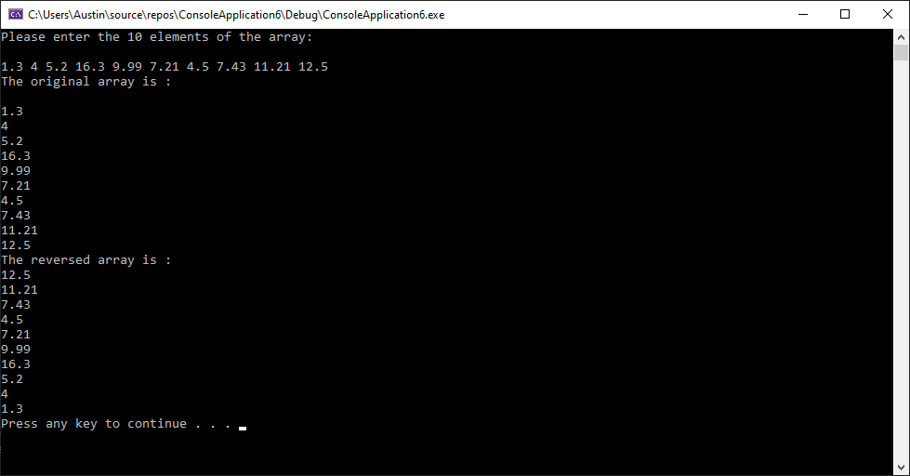

**5B:**

/*

a. Program Description : This program takes two user input arrays and combines them into a single array.

b. Author : Austin Ngo

c. Input variables : in

d. Process Flow : User inputs first array, then second array, program then combines both and outputs the result.

e. Output variables : arr, arrNew, size

*/

#include <iostream>

#include <cmath>

#include <string>

#include <cstdlib>

#include <iomanip>

#include <math.h>

#include <algorithm>

using namespace std;

double* arr = new double[10];

double* read_data(double& size)

{

int i = 0;

double in;

if (size >= 10)

{

size = size * 2;

double* arrNew = new double[size];

for (i = 0;i < size / 2;i++)

arrNew[i] = arr[i];

delete[] arr;

arr = arrNew;

}

while (1)

{

cout << "Please enter the elements of the array individually, press 'enter' after every element and press '0' to quit." << endl;

cin >> in;

if (in == 0)

break;

else

arr[i++] = in;

}

size = i;

return arr;

}

int main()

{

double size = 0;

double* a = read_data(size);

cout << "Size of array : " << size << " elements." << endl;

cout << "Array elements : \n";

for (int i = 0;i < size;i++)

cout << a[i] << " ";

cout << endl;

a = read_data(size);

cout << "New size of array: " << size << " elements. " << endl;

cout << "Array elements: ";

for (int i = 0;i < size;i++)

cout << a[i] << " ";

cout << endl;

return 0;

}

5B Test Cases: